USER GUIDE

Edit error form

September 2018

Version 1.01

Pharmacon ITC303/309 Group

Document Revisions

|  |  |  |
| --- | --- | --- |
| Date | Version Number | Document Changes |
| 15/09/2018 | 1.01 | Initial |
|  |  |  |
|  |  |  |
|  |  |  |
|  |  |  |
|  |  |  |
|  |  |  |
|  |  |  |
|  |  |  |

Table of Contents

1 Introduction 4

1.1 Scope and Purpose 4

1.2 Process Overview 4

2 Edit Error Form 5

2.1 Login – Administration User 5

2.1.1 To Log in to Pharmacy Error Tracker (PET) 5

2.2 Manage Error Form 6

2.2.1 To Edit Error Form 6

2.2.2 Manage Edit Error Form changes 9

2.2.3 Example of Edit Error Form changes 11

# Introduction

## Scope and Purpose

The purpose of this user guide is to provide instructions on how to edit the error form, i.e. hide fields not required by the workplace, or restore hidden fields.

No other features of the Pharmacy Error Tracker (PET) application will be discussed in this user guide.

* To be able to use PET, the user will need basic knowledge of logging into an online application and using a manage function to create a record.
* This feature is only available to a user with administrator rights.

## Process Overview

The administrator will need to log into PET using their valid username and password.

* The Welcome Page will be presented on successful login.
* The administrator will need to select Manage Error Form via the menu bar or the button on the menu page.

# Edit Error Form

To edit the error form, the administrator will need to launch the application, login with a valid user name and password with administration rights. Using the Manage Error Form, the administrator can manage the fields that will be available in the Log Error form.

NOTE: Only fields that are *not* able to be hidden are the date and time fields.

## Login – Administration User

User must have access to the application.

User must have a valid username and password with administration rights.

### To Log in to Pharmacy Error Tracker (PET)

1. Launch the application.
2. Click in the Username field.
3. Enter username.
4. Tab or click in Password field.
5. Enter password.

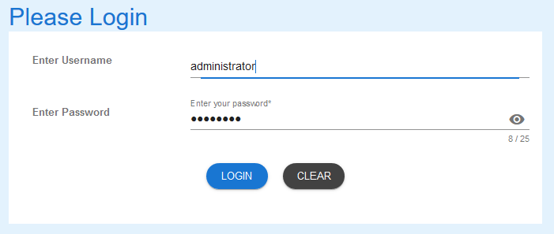

1. Select LOGIN to access PET.

NOTE: Users entering an invalid username and/or password will not beable to access PET.

## Manage Error Form

### To Edit Error Form

1. From the Welcome Page, there are two ways to navigate to “Manage Error Form”:
   1. Select the “Manage Error Form” from the list



* 1. From the Menu Bar, hover your mouse over “Manage…” and select “Manage Error Form”

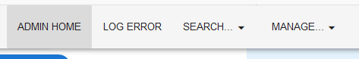

1. The Edit Error form will appear.

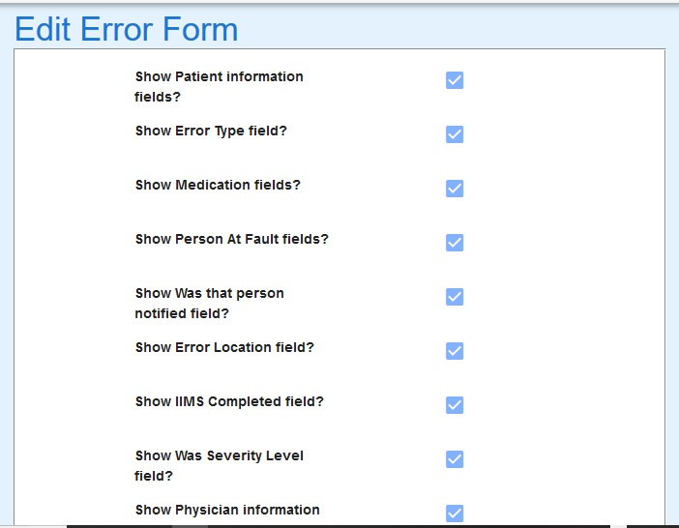

1. To hide fields from the Log Error form, “untick” the box relating to the fields to be hidden.

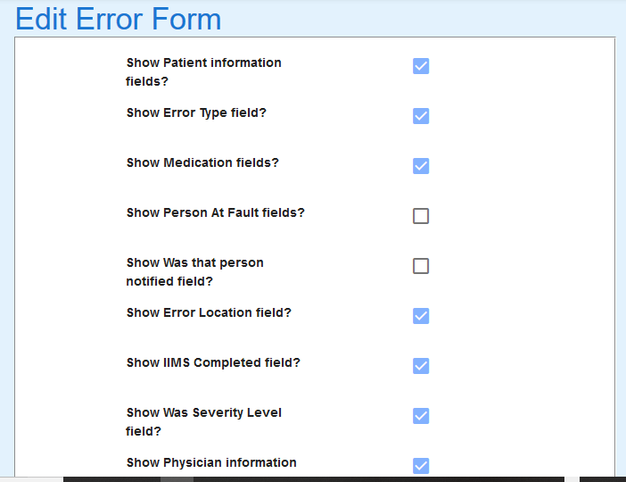

### Manage Edit Error Form changes

1. From Select the SUBMIT button to save changes, RESET TO DEFAULT to reset Log Error form to default (all fields showing), or UNDO CHANGES to cancel changes made.

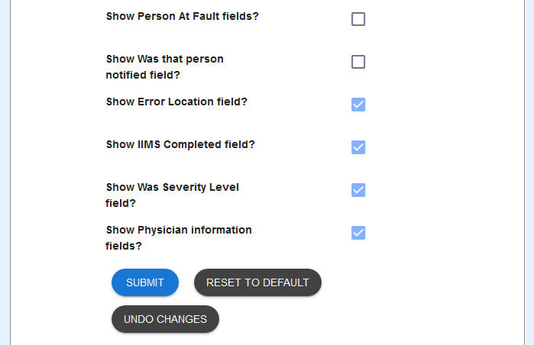

1. Form updated message is returned upon Submit being selected.



1. Form reset to default message is returned upon Reset To Default is selected. All field boxes are also ticked.



1. Undo success message is returned upon Undo Changes is selected. Field boxes that were unselected, are reset to selected.

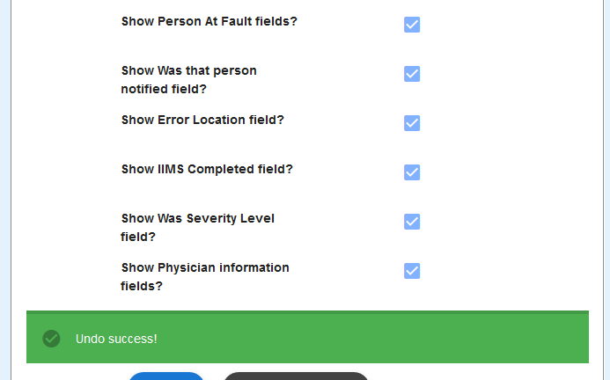

### Example of Edit Error Form changes

1. From Log Error form before changes are made to Person At Fault fields

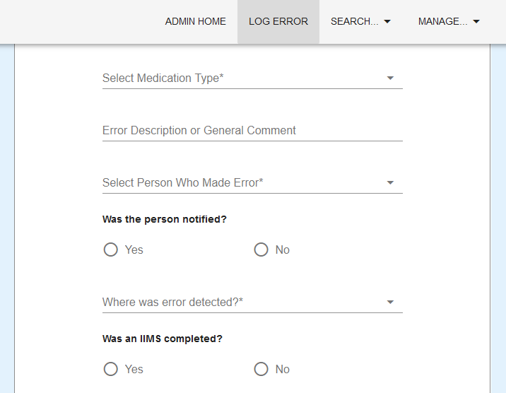

1. Changes made to Edit Error Form to hide Person At Fault and Was that Person Notified field.



1. Log Error form after changes have been submitted.  
     
   Arrow indicates where the hidden fields would normally appear.

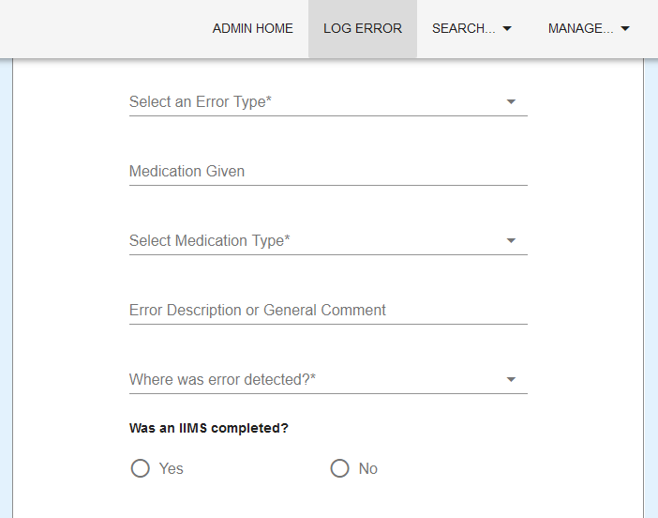

If you encounter issues not manageressed by this user guide, please contact your account manager for manageitional support.